Châteauneuf-du-Pape is a commune in the Vaucluse department in the Provence-Alpes-Côte d'Azur region in southeastern France. The village lies about 3 kilometres (1.9 mi) to the east of the Rhône and 12 kilometers (7.5 mi) north of the town of Avignon.

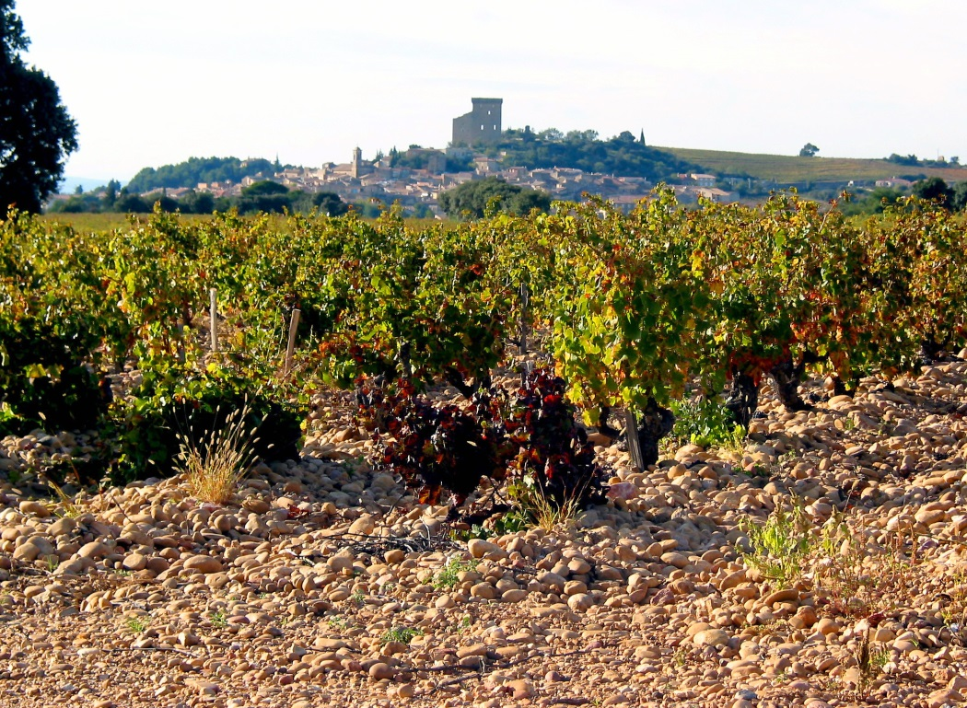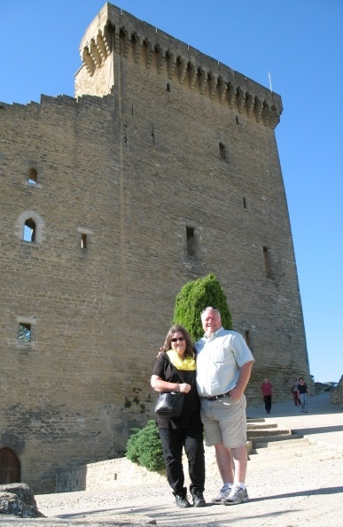

A ruined mediaeval castle sits at the top of the village and dominates the landscape to the south. It was built in the 14th century for Pope John XXII, the second of the popes who resided in Avignon. The commune is famous for the production of red wine and almost all the cultivable land is planted with grapevines.

Châteauneuf-du-Pape roughly translates to "The Pope's new castle" and, indeed, the history of this appellation is firmly entwined with papal history. In 1308, Pope Clement V, former Archbishop of Bordeaux, relocated the papacy to the town of Avignon. Clement V and subsequent "Avignon Popes" were said to be great lovers of Burgundy wines and did much to promote it during the seventy-year duration of the Avignon Papacy. At the time, wine-growing around the town of Avignon was anything but illustrious. While the Avignon Papacy did much to advance the reputation of Burgundy wines, they were also promoting viticulture of the surrounding area, more specifically the area 5-10 km north of Avignon close to the banks of the Rhône River. Prior to the Avignon Papacy, viticulture of that area had been initiated and maintained by the Bishops of Avignon, largely for local consumption.

Clement V was succeeded by John XXII who regularly drank the wines from the vineyards to the north did much to improve viticultural practices in Châteauneuf-du-Pape. Under John XXII, the wines of this area came to be known as "Vin du Pape", this term later to become Châteauneuf-du-Pape. John XXII is also responsible for erecting the famous castle that stands as a symbol for the appellation.

In the 18th century, the wines were shipped under the name vin d'Avignon. Records from the early 19th century mention wines of the name Châteauneuf-du-Pape-Calcernier that seems to have been a lighter-style wine than the Châteauneuf-du-Pape of today. They seem to have increased in reputation within France until phylloxera hit in the early 1870s, which was earlier than most other French wine regions were affected. Prior to World War I the bulk of Châteauneuf-du-Pape was sold to Burgundy as vin de médecine to be added to Burgundy wine to boost the strength and alcohol levels.

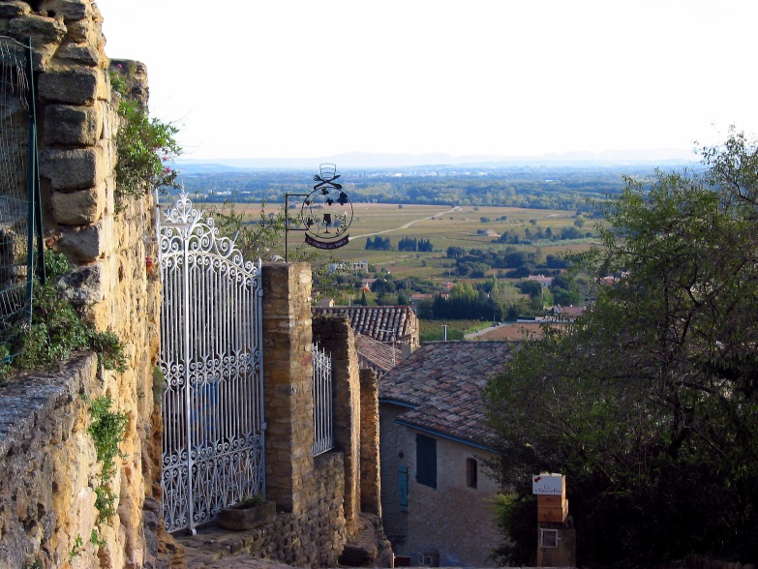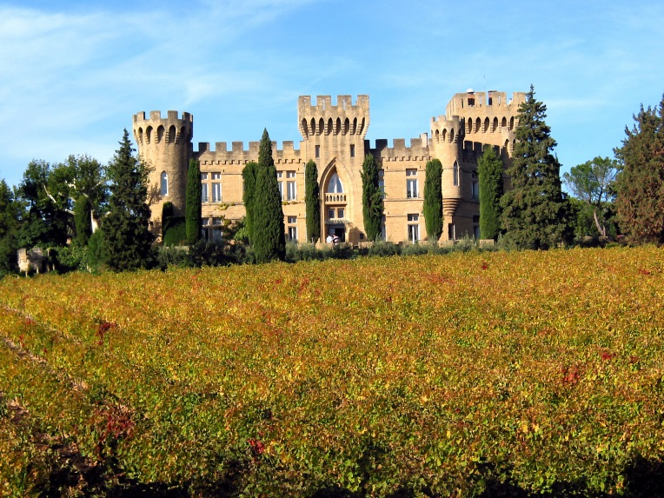

Châteauneuf-du-Pape wine is a specific French wine from the Appellation d'origine contrôlée (AOC) located around the village of Châteauneuf-du-Pape in the Rhône wine region in southeastern France. It is one of the most renowned appellations of the southern part of the Rhône Valley. Vineyards are located around Châteauneuf-du-Pape and in the neighboring villages Bédarrides, Courthézon and Sorgues between Avignon and Orange and cover slightly more than 3,200 hectares or 7,900 acres (32 km²). Over 110,000 hectolitres of wine a year are produced here. More wine is made in this one area of southern Rhône than in the entirety of the northern Rhône region.

Early AOC regulations: Vineyard with the Châteauneuf-du-Pape appellation borders, with vines trimmed as bushvines. In the early 20th century, Châteauneuf-du-Pape was plagued by wine fraud with various rules for the production of wine, drawn up and promulgated in 1923, became the first Appellation Contrôlée rules in France, and provided the prototype for subsequent AOC rules. The original AOC rules allowed ten varieties, and were amended to thirteen in 1936, and eighteen in 2009. Baron Pierre le Roy Boiseaumarié of Château Fortia was the principal architect of these regulations, which set the minimum alcohol level of the wines and set limits on yields as well as which types of grapes could be grown in which area. Another one of the Baron's requirements was that no vineyards could be planted on land that wasn't arid enough to support plantings of both lavender and thyme. The producers of Châteauneuf-du-Pape have historically been known to be fiercely protective of their vineyard properties which is said to have led to the 1954 passing of a municipal decree in the village of Châteauneuf-du-Pape that banned the overhead flying, landing or taking off of flying saucers in the commune, this law has yet to be repealed.

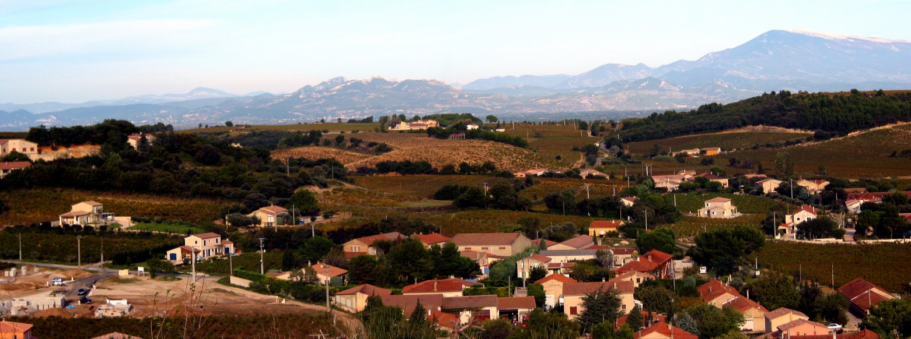

The appellation stretches from the eastern bank of the Rhône River near Orange in the north-west to Sorgues near Avignon in the south-east. The altitude reaches 120 meters at its highest and is in the northern part of the appellation. It covers 3200 hectares of land with at least three distinct types of soil or terroirs. In the north and north-east the famous galets roulés, round rocks or pebbles covering the clay soil. The rocks are famous for retaining the heat from the plentiful sun, some 2800 hours a year, releasing it at night, ripening the grapes faster than in the eastern part of the appellation, where the soil is mostly sand, as well as to the south where the soil is more gritty. The powerful mistral wind carries away the moisture, intensifying the dry climate.

Terroir: The characteristic terroir of Châteauneuf-du-Pape comes from a layer of stones called galets ("pebbles"). The rocks are typically quartzite and remnants of Alpine glaciers that have been smoothed over millennia by the Rhône River. The stone retains heat during the day and releases it at night which can have an effect of hastening the ripening of grapes. The stones can also serve as a protective layer to help retain moisture in the soil during the dry summer months. Some of the most prestigious vineyards in the area, like Chateau Rayas, have more traditional looking vineyards without the galets. These are most often vineyards located on south-facing slopes where the night-time radiated heat from the stones would be detrimental to the vines and cause over-ripening of the grapes.

La Crau: La Crau is by far Chateauneuf-du-Pape's most famous lieu-dit or vineyard. The vineyard is owned primarily by Domaine du Vieux Télégraphe, one of the most classic Chateauneuf's, but also producer Henri Bonneau maintains a firm position here. The vineyard is very rich in the aforementioned galets roulés, while Domaine du Vieux Lazaret with its over 100 ha owned by Vignobles Jérôme Quiot is the largest.

Châteauneuf-du-Pape exists as red and white wine, with the large majority of the wines produced being red. The appellation rules do not allow rosé wines to be made. The wines have traditionally been packaged in distinctive, heavy dark wine bottles embossed with papal regalia and insignia, however in recent times a number of producers have dropped the full papal seal in favor of a more generic icon, while still retaining the same heavy glassware.

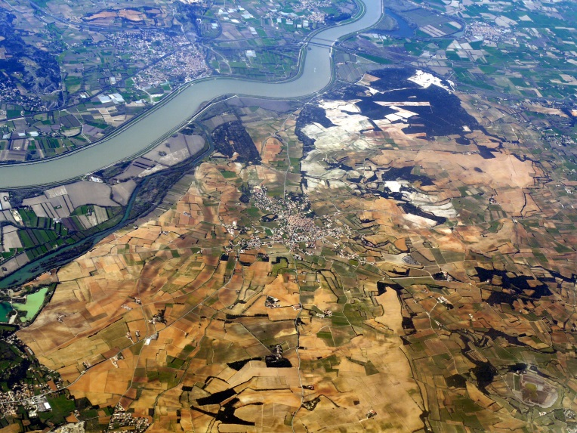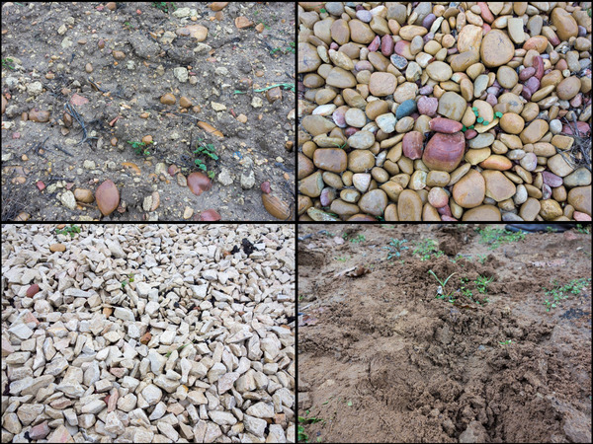

Grape varieties: Châteauneuf-du-Pape is traditionally cited as allowing thirteen grape varieties to be used, but the 2009 version of the AOC rules in fact list eighteen varieties, since blanc (white), rose (pink) and noir (black) versions of some grapes are now explicitly listed as separate varieties. Also in the previous version of the appellation rules, Grenache and Picpoul were associated with different pruning regulations in their noir and blanc versions, bringing the number of varieties previously mentioned from thirteen to fifteen.

Red varieties allowed are Cinsaut, Counoise, Grenache Noir, Mourvèdre, Muscardin, Piquepoul Noir, Syrah, Terret Noir, and Vaccarèse (Brun Argenté).

White and pink varieties are Bourboulenc, Clairette Blanche, Clairette Rose, Grenache Blanc, Grenache Gris, Picardan, Piquepoul Blanc, Piquepoul Gris, and Roussanne. (The varieties not specifically mentioned before 2009 are Clairette Rose, Grenache Gris and Piquepoul Gris.)

Both red and white varieties are allowed in both red and white Châteauneuf-du-Pape. There are no restrictions as to the proportion of grape varieties to be used, and unlike the case with other appellations, the allowed grape varieties are not differentiated into principal varieties and accessory varieties. Thus, it is theoretically possible to produce varietal Châteauneuf-du-Pape from any of the eighteen allowed varieties. In reality, most Châteauneuf-du-Pape wines are blends dominated by Grenache. Only one of every 16 bottles produced in the region is white wine.

With 72% of the total vineyard surface in 2004, Grenache noir is very dominant, followed by Syrah at 10.5% and Mourvèdre at 7%, both of which have expanded in recent decades. Cinsaut, Clairette, Grenache Blanc, Roussanne and Bourboulenc each cover 1-2.5%, and the remaining seven varieties each account for 0.5% or less.

It is common to grow the vines as gobelets (bushvine), and this is the only vine training system allowed for the first four red varieties. Yields are restricted to two tons per acre.

Winemaking Style: Châteauneuf-du-Pape wines are often high in alcohol, typically 13-15%, and must be minimum 12.5% under the appellation rules with no chaptalization allowed. Winemaking in the region tends to focus on balancing the high sugar levels in the grape with the tannins, and phenols that are common in red Châteauneuf-du-Pape. Following harvest, the grape clusters are rarely destemmed prior to fermentation. The fermentation temperatures are kept high, with the skins being frequently pumped over and punched down for the benefit of tannin levels and color extraction to achieve the characteristic dark Châteauneuf color. Beginning in the 1970s, market tendencies to prefer lighter, fruitier wines that can be drunk sooner have prompted some estates to experiment with carbonic maceration. Low yields are considered critical to the success of Châteauneuf-du-Pape with the principal grape varieties tending to make thin and bland wine when produced in higher quantities. The AOC requirements limit yields to 368 gallons per acre, which are nearly half the yields allowed in Bordeaux.

The common technique of using small barrel oak is not widely used in the Châteauneuf-du-Pape area, partly due to the fact that the principal grape Grenache is prone to oxidation in the porous wooden barrels. Instead, Grenache is vinified in large cement tanks, while the other grape varieties are made in large old barrels called foudres that do not impart the same "oaky" characteristics as the smaller oak barrels.

Chateauneuf du Pape | Vintage | Verietals | Alcohol | Cost | Votes | Grand Ranking
Tiare Imperiale | 2010 | All 13; GSMCC | 14.5% | $22.99 | 7 | 4
Le Celestiere Cuvee La Croze | 2010 | 100% G | 15.5% | $29.99 | 5 | 5
Chateau Fortia Tradition | 2010 | 65% G, 20% S, 15% M | 15.0% | $32.61 | 10 | 2
Xavier Vignon Tradition | 2009 | 55% G, 35% M, 10% S | 14.5% | $33.08 | 23 | 1
Clos St Michel, Tradition | 2009 | 40% G, 30% S, 30% M | 14.5% | $36.74 | 7 | 4
Xavier Vignon Cuvee Anonyme | 2009 | 25% G, 25% S, 25% M, 25% CC | 14.5% | $46.19 | 8 | 3

